Name: _________________ PS ID # ___ COSC 3380

Exam 2

A. (60 points) SQL

Below you will find a University Database:

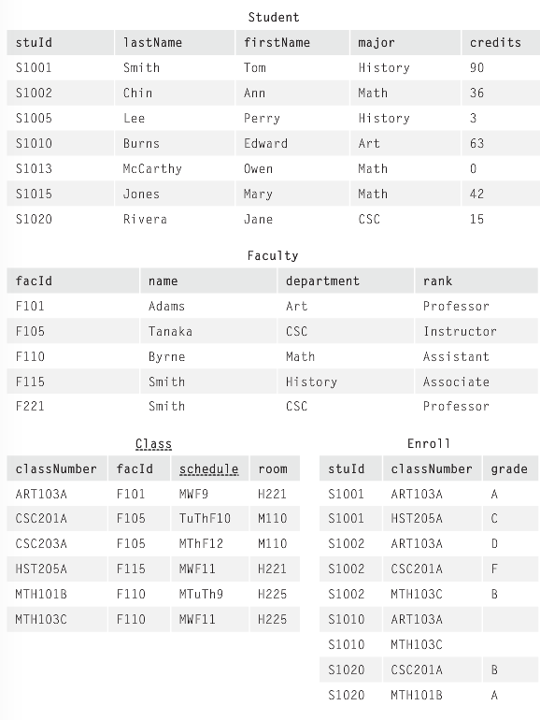

Write the “compilable” SQL query together with the resulting Relation and the tuples in it.
No Relation and tuples- 3 pts

1. (5 points)
Get the class number of all classes in which students are enrolled.

ANSWER:

2. (5 points)
Get names of all math majors who have more than 30 credits.

ANSWER:

3. (5 points)
Find IDs and names of all students taking ART103A.

ANSWER:

4. (10 points) (SELECT; SELECT)
Find the numbers of all the classes taught by Byrne of the Math department.

ANSWER:

5. (5 points) (COUNT; DISTINCT)
No Relation and tuples- 3 pts
Find the total number of students enrolled in ART103B.

ANSWER:

6. (5 points) (SUM)
Find the sum of all the credits that history majors have.

ANSWER:

7. (5 points) (SUM)
Find each major, find the sum of all the credits the students with that major have.

ANSWER:

8. (5 points) (COUNT)
Find each class, show the number of students enrolled.

9. (5 points) (LIKE)
Get details of all math courses.

ANSWER:

10. (10 points) (VIEW)
Assume a user needs a table ClassList containing the IDs and names of all students in class CSC101.

ANSWER:

B. (40 points)

1. (2 points)
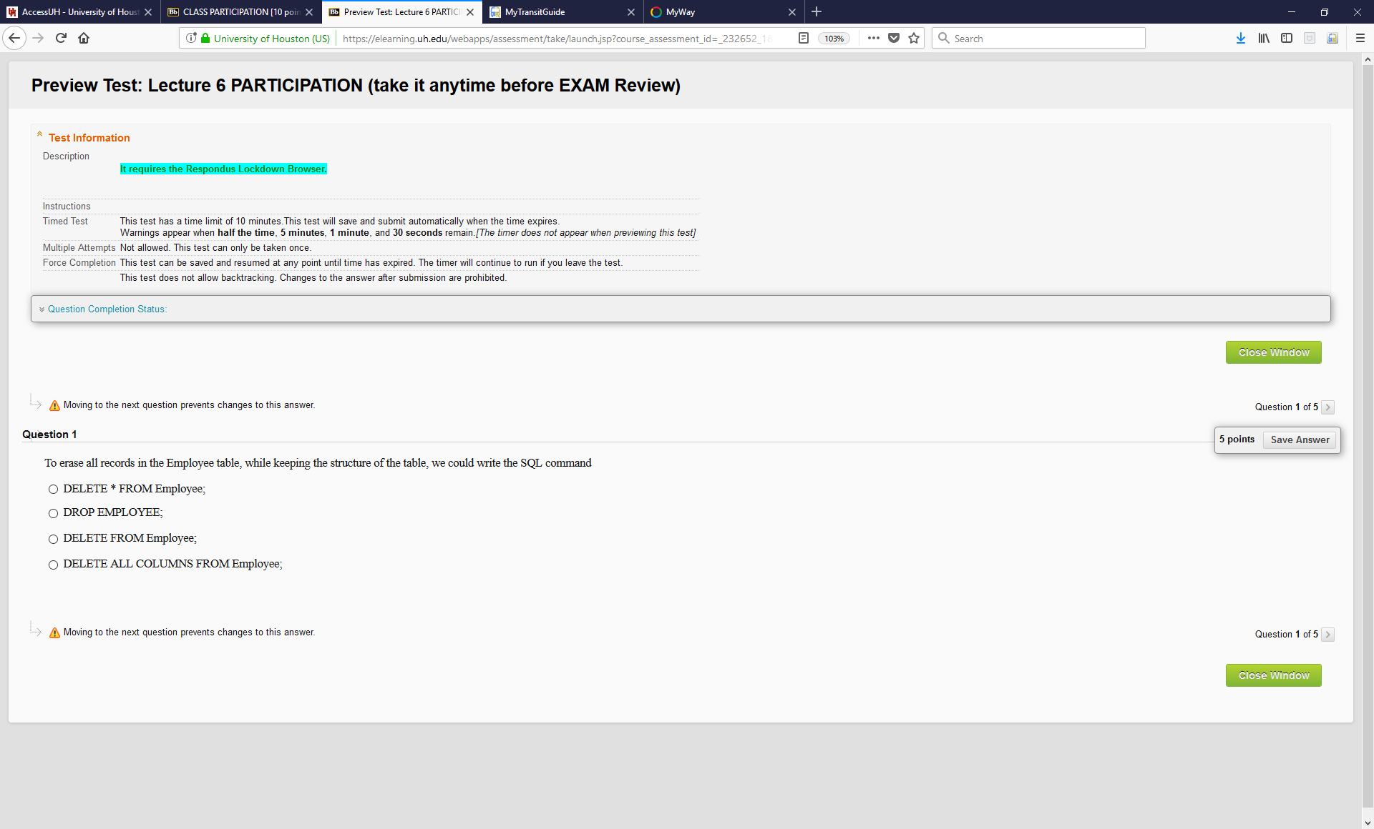

2. (2 points)

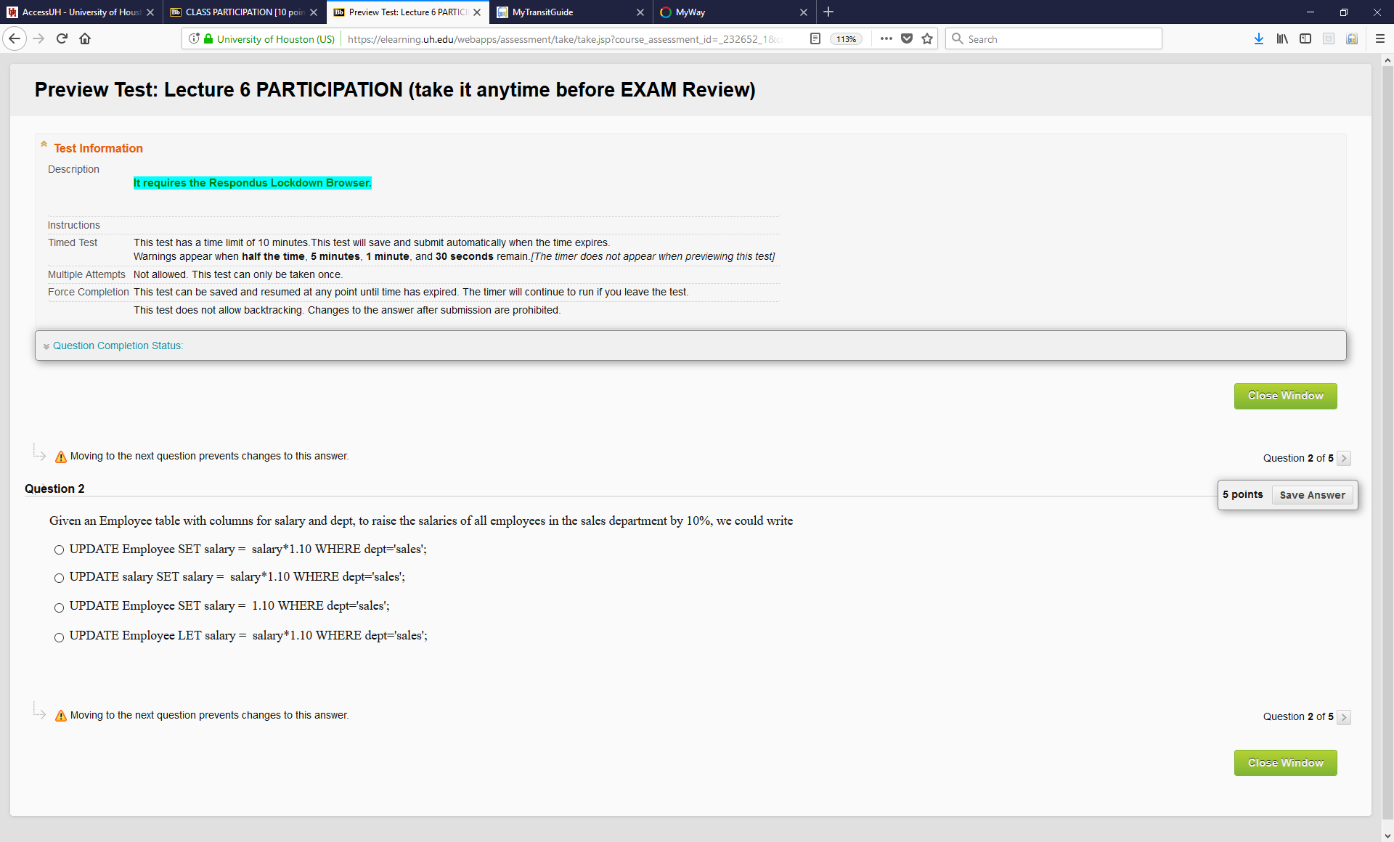

3. (2 points)

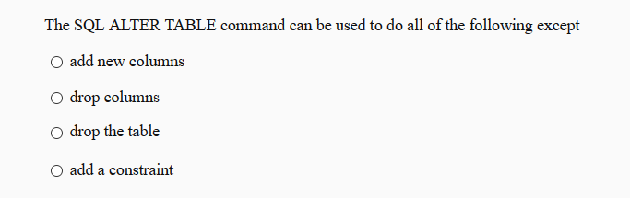

4. (2 points)

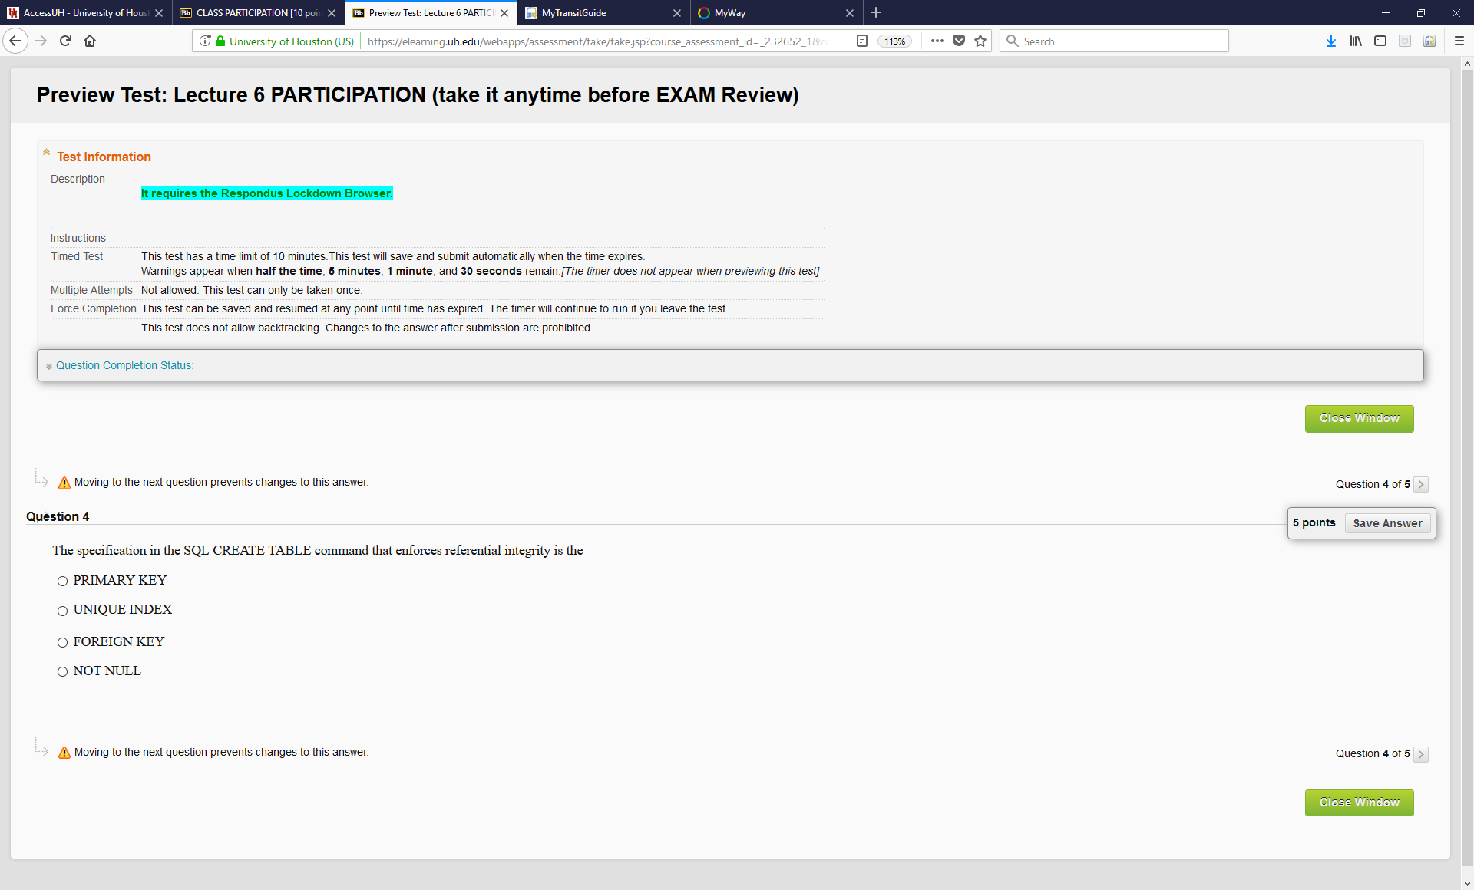

5. (2 points)

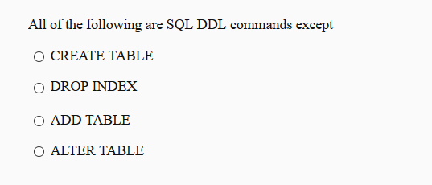

6. (2 points)

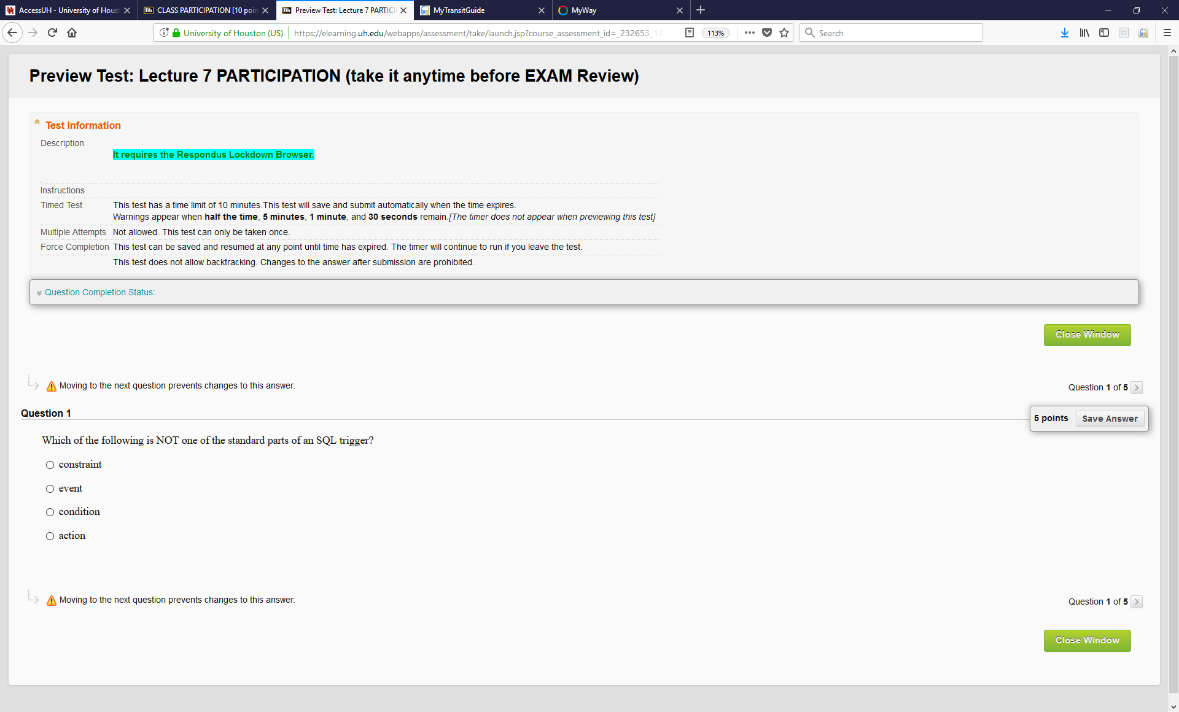

7. (2 points)

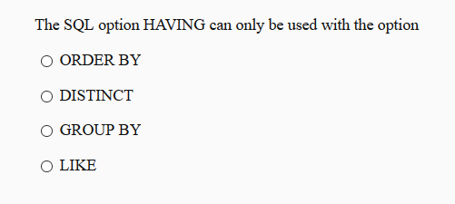

8. (2 points)

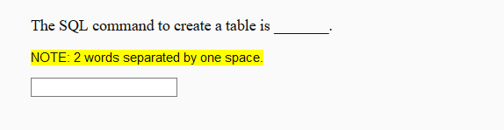

9. (2 points)

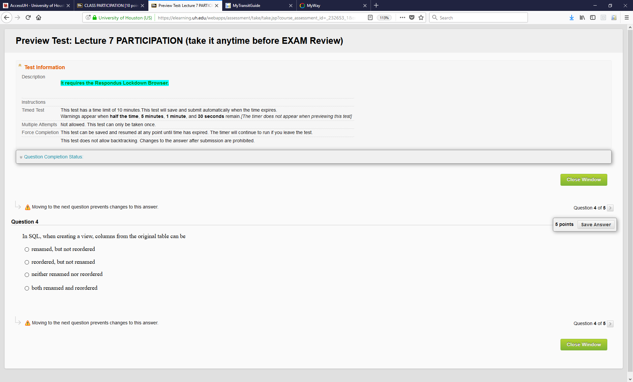

10. (2 points)

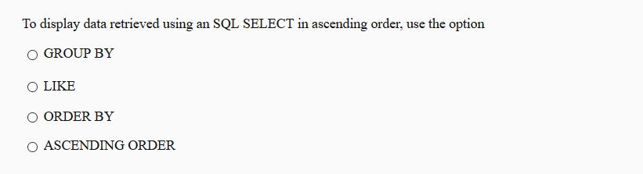

11. (2 points)

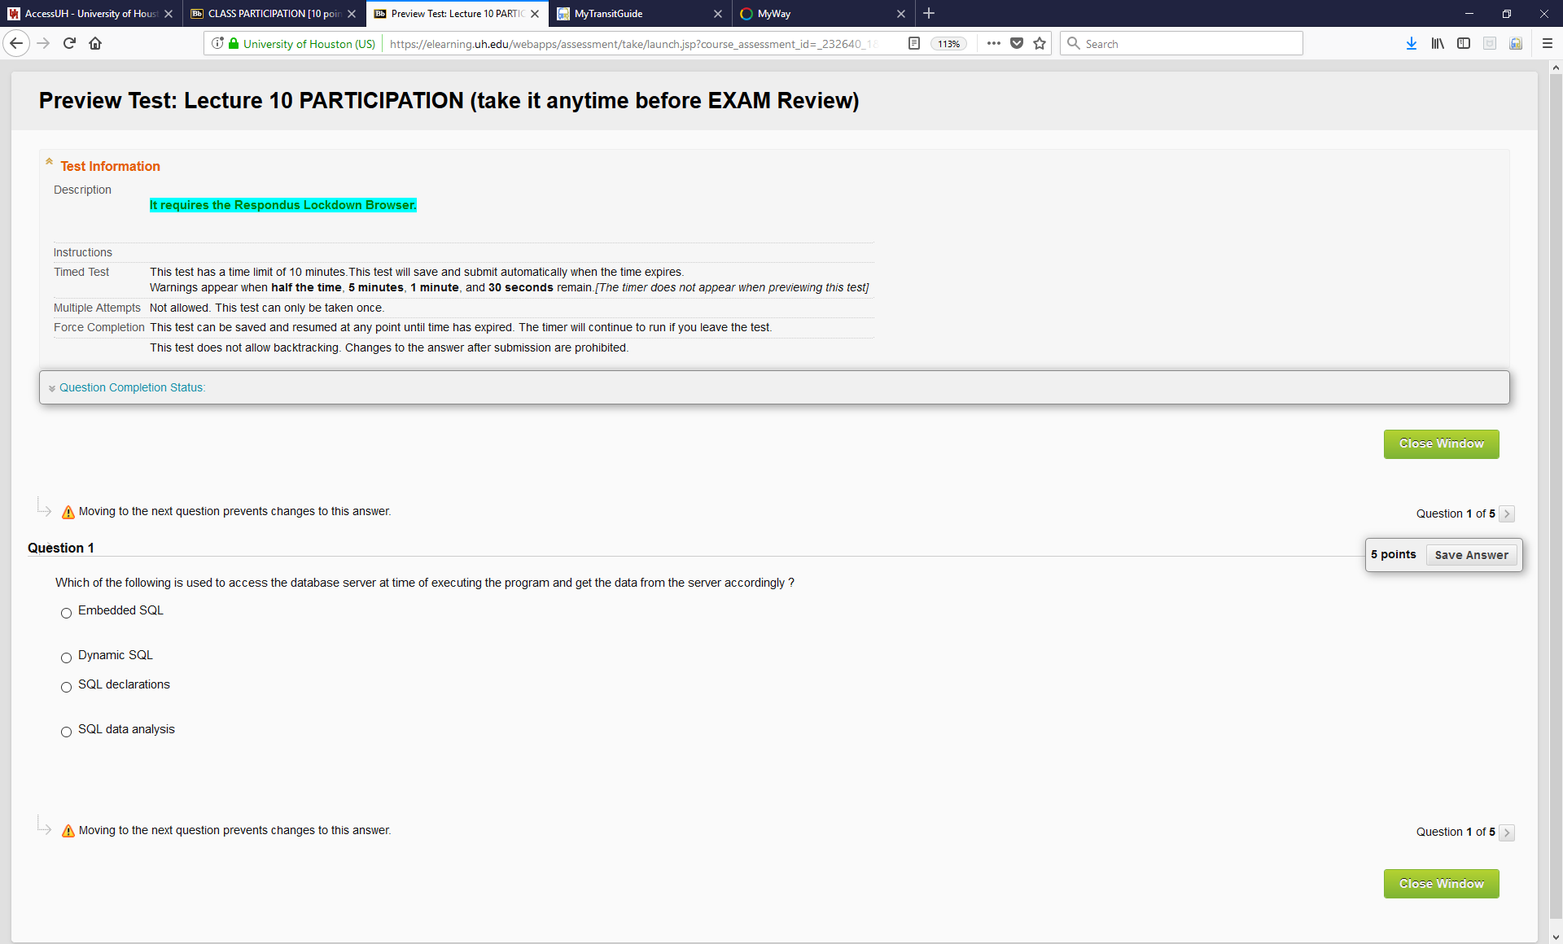

12. (2 points)

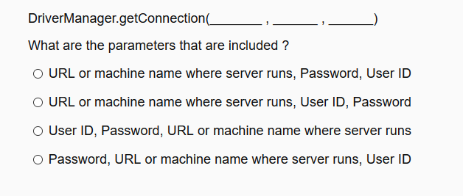
13. (2 points)

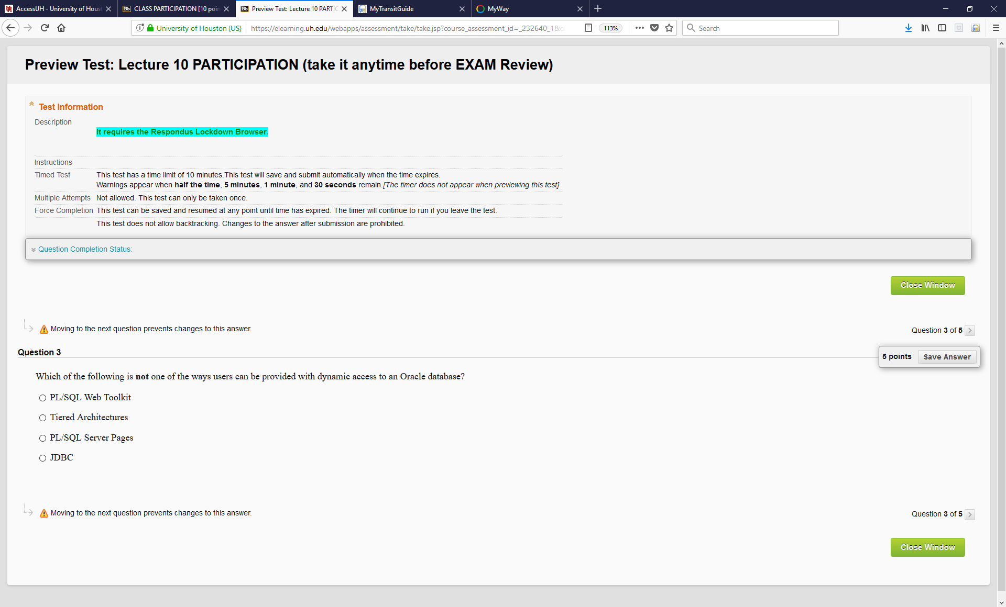

14. (2 points)

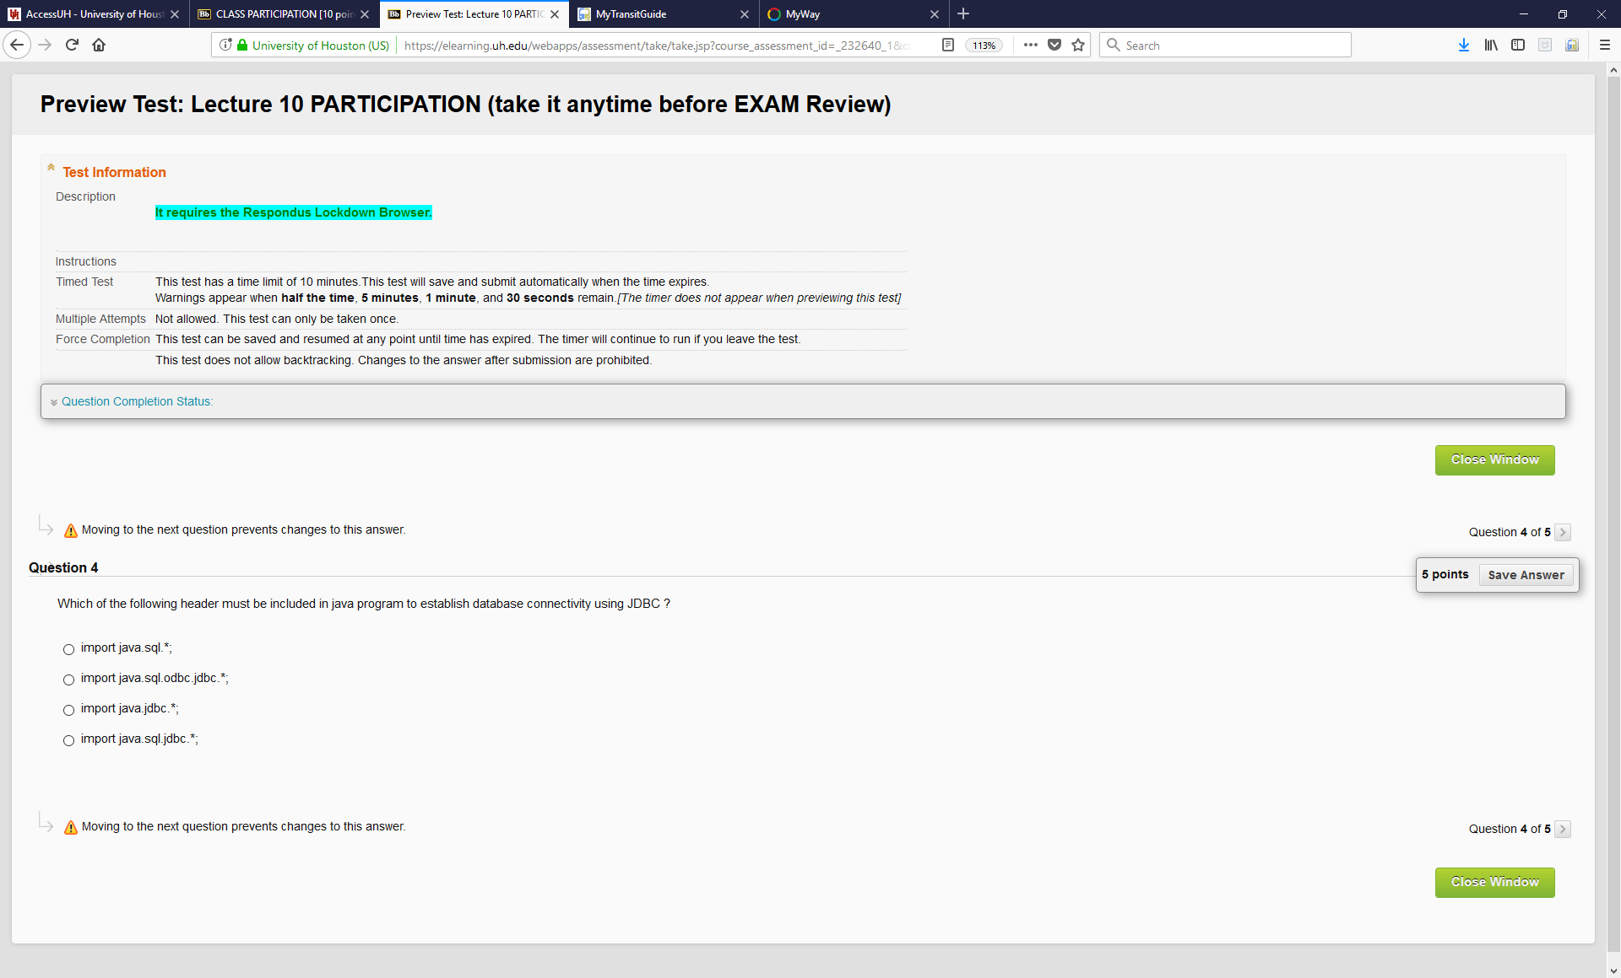

15. (2 points)

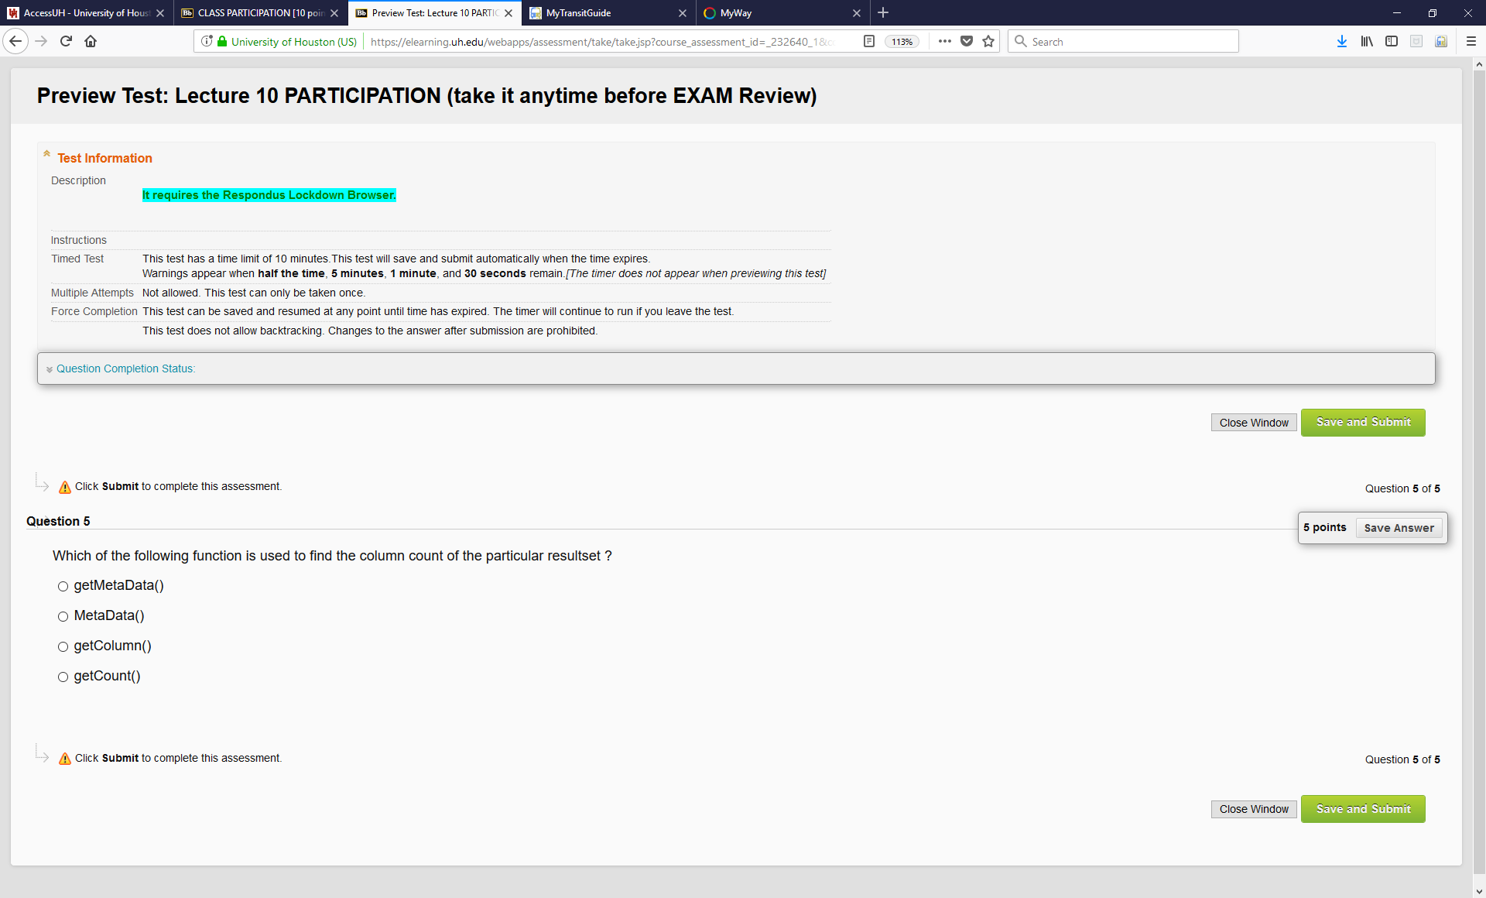

16. (2 points)

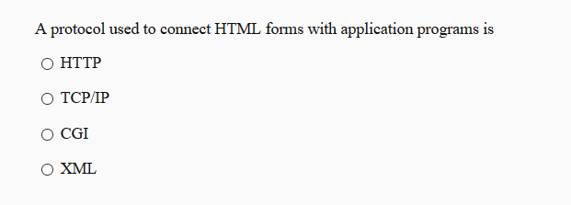

17. (2 points)

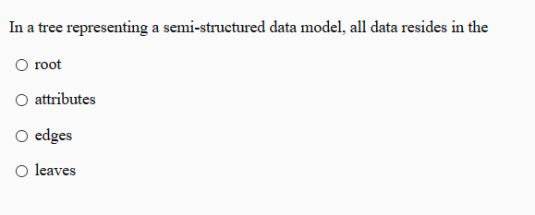

18. (2 points)

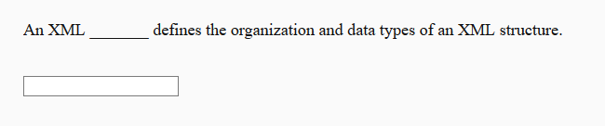

19. (2 points)

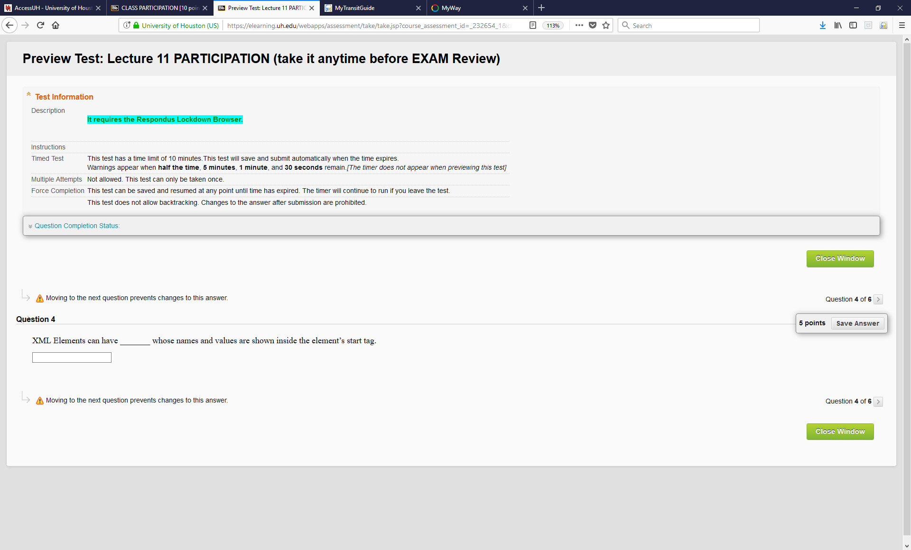

20. (2 points)

